PROJECT PROPOSAL
Artificial Intelligence
Muhammad Akif Naveed
FA24-BSE-129



Project title:
NOVA AI — A Voice-Controlled Intelligent Personal Assistant with NLP-Based Intent Recognition, Real-Time Automation Vision-Based Gesture Control and Backend Memory

Supervised By:
MAM MAIRA AFZAL

Core philosophy: NOVA (Neural Orchestrated Voice Assistant) is a backend-heavy, voice-first intelligent assistant running on Windows. Minimal UI, maximum capability. The interface is a HUD-style dark overlay — not a full app window. NOVA is always partially alive (gesture engine running), and fully awakens on the wake word "Hey NOVA".

🏗️ SYSTEM ARCHITECTURE
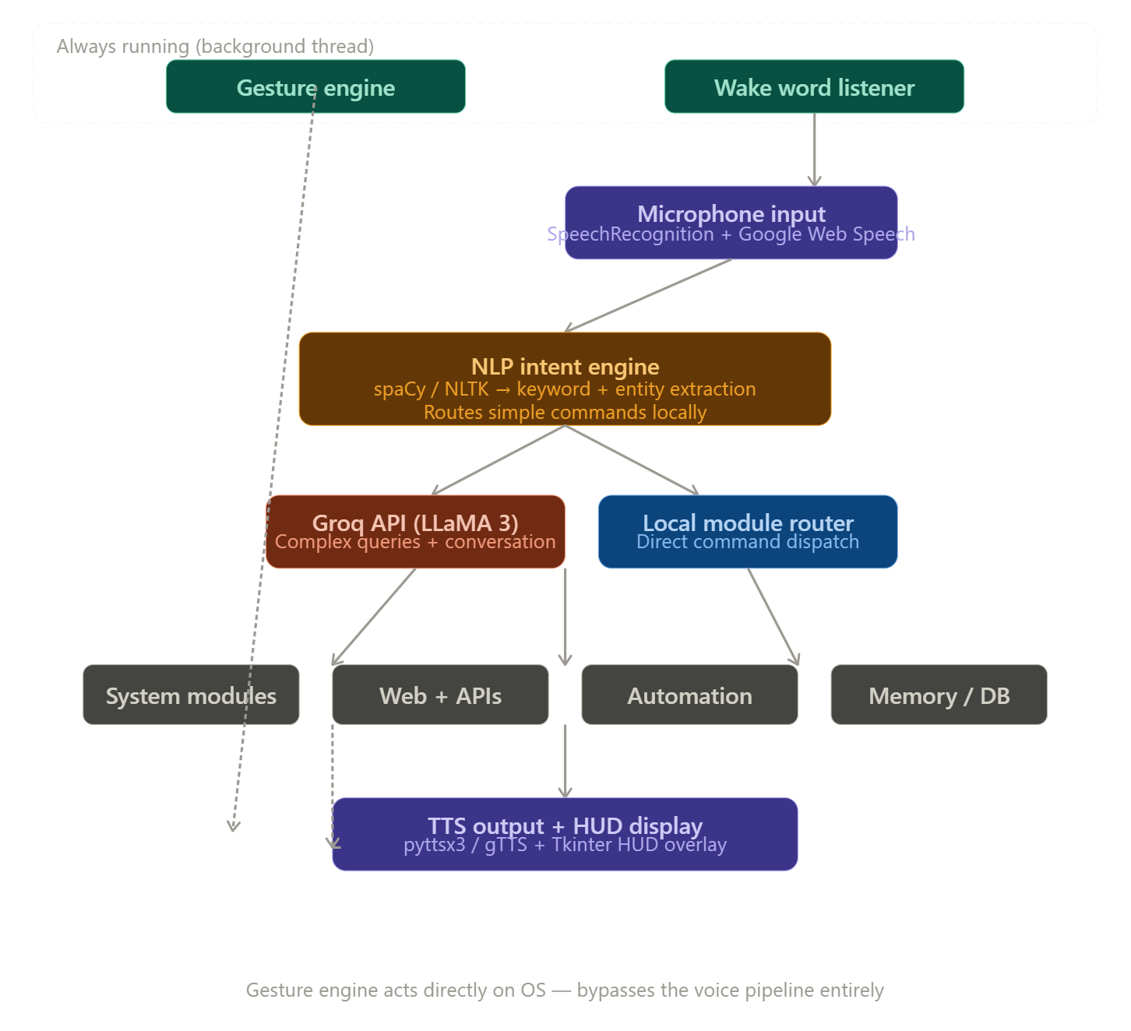

📦 MODULE-BY-MODULE BREAKDOWN

🟣 MODULE 1 — Wake Word Detection
What it does: NOVA is in a low-power "ear" state at all times. The moment it hears "Hey NOVA", it activates fully.
- Language: Python
- Library: SpeechRecognition (continuous ambient listen loop), pvporcupine (offline wake word detection — free tier available) or a simple keyword energy threshold
- Concept: Runs on a background thread — never blocks the main app. Listens passively using low CPU audio energy scanning. On detection, triggers the main voice pipeline.
- Thread safety: Uses Python threading.Event to signal activation to the main loop

🎙️ MODULE 2 — Speech-to-Text (STT)
What it does: Converts your spoken command into text after NOVA wakes.
- Library: SpeechRecognition with Google Web Speech API backend (free, no key needed for basic use)
- Fallback: Whisper (OpenAI open-source, runs locally, offline) for privacy mode
- Concept: Mic captures audio → silence detection cuts the clip → sent to Google Web Speech → returns text string
- Key config: Adjustable pause_threshold and energy_threshold for Wah Cantt ambient noise

🧠 MODULE 3 — NLP Intent Recognition Engine
What it does: The first brain layer — classifies your command and extracts key entities before deciding whether to call Groq or handle locally.
- Libraries: spaCy (fast NER — extracts names, cities, times, app names) + NLTK (tokenization, stopword removal)
- Concept: Intent classification using rule-based patterns first (if "weather" in tokens → WeatherModule). Entity extraction grabs the payload (e.g. "Islamabad" from "weather in Islamabad")
- Why NLP here and not just Groq? Speed and cost. For simple commands like "open Chrome" or "what time is it", NLP handles it in milliseconds locally. Groq is reserved for complex, conversational, or ambiguous inputs
- Intent categories defined: System, Web, Information, Automation, Memory, Creative, Conversation

🤖 MODULE 4 — Groq LLM (The Second Brain)
What it does: Handles complex queries, follow-up questions, general conversation, email drafting, and anything NLP can't classify confidently.
- API: Groq API (free tier — LLaMA 3 70B, ultra-fast inference)
- Concept: Stateful conversation via message history array. Each call includes a system prompt defining NOVA's personality + a rolling conversation window
- System prompt includes: NOVA's name, personality (professional but friendly), knowledge of user (Akif, SE student, Wah Cantt), current date/time context
- Memory injection: Before each Groq call, relevant memories from SQLite are injected into the system prompt
- Use cases: Drafting emails, answering complex questions, explaining code, general chat, creative writing

🌤️ MODULE 5 — Weather Information
What it does: Fetches real-time weather for any city.
- API: OpenWeatherMap (free tier — 60 calls/min)
- Library: requests
- NLP trigger: Entity "city name" extracted → passed to API
- Output: "It's currently 28°C in Islamabad, feels like 31, humidity 65%, clear skies."
- Default city: Wah Cantt stored in memory/config

📰 MODULE 6 — News & Space Updates
What it does: Fetches today's space/science news.
- API: NASA Open API (APOD — Astronomy Picture of the Day, completely free)
- Library: requests
- Output: NOVA reads the title and explanation of today's NASA APOD, plus a fun science fact
- Extensible: Can add RSS parsing for general news later (no API key needed)

📖 MODULE 7 — Wikipedia Knowledge Base
What it does: Answers "tell me about X" questions with concise summaries.
- Library: wikipedia (Python package, free, no key)
- Concept: Extracts first 3 sentences of the summary for a given search term
- Disambiguation handling: If multiple results, NOVA asks "Did you mean X or Y?"

🌐 MODULE 8 — Web Automation & Browser Control
What it does: Opens specific websites and performs web actions by voice.
- Libraries: webbrowser (simple opens), selenium (for interactions like clicking, scrolling, liking posts)
- Sites NOVA can open by voice:
  - GitHub profile → github.com/[username]
  - LinkedIn profile → linkedin.com/in/[username]
  - YouTube, Google, StackOverflow, ChatGPT, Gmail, Google Drive, WhatsApp Web
  - University portal
- Actions (Selenium-powered):
  - "Like this post" → finds and clicks the like button on LinkedIn/YouTube
  - "Comment [text] on this" → finds comment box, types, submits
  - "Scroll down" → JS scroll (also controllable via hand gesture)
  - "Search for [query] on YouTube"
- Config file: sites.json storing name → URL mappings (easily extensible)

💻 MODULE 9 — Application Launcher
What it does: Opens any installed Windows app by voice.
- Library: os, subprocess
- Apps list (finalized):
  - VS Code, Chrome, Firefox, Notepad, Calculator
  - Spotify, VLC Media Player
  - File Explorer, Task Manager, Control Panel
  - WhatsApp Desktop, Discord, Telegram
  - PowerPoint, Word, Excel
  - GitHub Desktop, Postman
- Config: apps.json — name → executable path mapping. User can add any app
- Fuzzy matching: fuzzywuzzy library handles "open visual studio" matching to "VS Code"

📧 MODULE 10 — Email Compose & Send
What it does: Drafts and sends emails fully by voice.
- Library: smtplib + email (Python built-in) for sending via Gmail SMTP
- Groq integration: "Write a professional email to my professor asking for assignment extension" → Groq drafts it → NOVA reads it back → "Send it? Say yes or no"
- Flow:
  - "Hey NOVA, write an email to Ali about the project meeting"
  - NOVA asks: "What should the email say?"
  - You describe it → Groq drafts full email
  - NOVA reads it aloud
  - "Send" → sends via Gmail SMTP / "Edit" → re-prompts
- Security: Gmail App Password stored in .env file (never hardcoded)

📱 MODULE 11 — WhatsApp Messaging
What it does: Sends WhatsApp messages by voice.
- Library: PyWhatKit
- Command: "Hey NOVA, send a WhatsApp to Mama saying I'll be home by 8"
- How it works: Opens WhatsApp Web → navigates to contact → types → sends
- Limitation noted: Requires Chrome + active WhatsApp Web session
- Contact book: contacts.json — stores name → phone number mappings

🎵 MODULE 12 — Music & Media Control
What it does: Plays music on YouTube or local files, and controls playback.
- Libraries: PyWhatKit (YouTube), os/subprocess (local VLC)
- Commands:
  - "Play lo-fi hip hop on YouTube"
  - "Play my playlist" → opens local music folder in VLC
  - "Pause / resume / next / previous" → via pyautogui keyboard shortcuts
  - "Play [song name]" → YouTube search + autoplay

📝 MODULE 13 — Notes & Reminders
What it does: Takes notes and sets time-based reminders.
- Storage: SQLite (memory.db — notes table and reminders table)
- Commands:
  - "Take a note: submit OOP assignment by Friday"
  - "Read my notes"
  - "Set a reminder for 5 PM to call Ali"
- Reminder engine: Background thread checks reminders table every minute → triggers TTS alert at the right time
- NLP: dateparser library converts "next Friday at 3pm" into a proper datetime object

📅 MODULE 14 — Calendar & Task Scheduling
What it does: Manages events and to-do tasks.
- Storage: SQLite (events and tasks tables)
- Commands:
  - "Add a calendar event: AI class on Monday at 9 AM"
  - "What do I have tomorrow?"
  - "Add to my task list: finish the NOVA project"
  - "Mark task [X] as done"
- Library: dateparser for natural language date parsing
- Display: HUD shows upcoming events on startup

⏰ MODULE 15 — Date, Time & Calculations
What it does: Tells time, date, countdowns, and does quick math.
- Library: datetime (built-in)
- Commands:
  - "What time is it?" / "What's today's date?"
  - "How many days until my semester ends?"
  - "What day is next Friday?"
- Math handled by NLP layer directly using eval() with safety sandboxing for arithmetic

🖥️ MODULE 16 — System Controls
What it does: Controls Windows system settings by voice.
- Libraries: os, psutil, screen_brightness_control, pycaw
- Commands:
  - "Shutdown / restart / sleep"
  - "Increase / decrease brightness"
  - "Mute / unmute / set volume to 60%"
  - "What's my battery?" / "How much RAM is being used?" / "CPU usage?"
  - "Lock the screen"
- Volume control: pycaw interfaces with Windows audio API directly

📸 MODULE 17 — Screenshot & Screen Tools
What it does: Takes screenshots and interacts with screen content.
- Library: pyautogui, Pillow
- Commands:
  - "Take a screenshot" → saves as screenshot_[timestamp].png to Desktop
  - "Click the [location] of the screen"
  - "Type [text]" → types it wherever cursor is

📋 MODULE 18 — Clipboard Manager
What it does: Reads and writes clipboard content by voice.
- Library: pyperclip
- Commands:
  - "What's in my clipboard?"
  - "Copy [text] to clipboard"
  - "Read what I copied"

🌍 MODULE 19 — Translation
What it does: Translates text between languages.
- Library: deep-translator (free, no key for basic use)
- Commands:
  - "Translate 'how are you' to Arabic"
  - "What does [word] mean in French?"
- Use case: Handy for your university work and communication

🧬 MODULE 20 — Memory System (NOVA Remembers You)
What it does: NOVA learns and remembers facts about you, your preferences, and conversation history.
- Storage: SQLite (memory.db — user_facts, conversation_log, preferences tables)
- Commands:
  - "Remember that my favourite editor is VS Code"
  - "Remember that Ali's number is 0300-XXXXXXX"
  - "What do you know about me?"
  - "Forget that I told you [X]"
- Auto-memory: After each Groq conversation, key facts are extracted and stored
- Startup injection: Top 10 most relevant memories injected into Groq system prompt

😄 MODULE 21 — Personality, Jokes & Small Talk
What it does: Gives NOVA a character — not just a cold command processor.
- Library: pyjokes (offline jokes)
- Groq: Handles open-ended banter, motivational quotes, philosophical questions
- Startup greeting: Time-aware — "Good evening Akif! It's 9 PM, you have 3 notes and a reminder at 10 PM."
- Roasting mode (optional fun feature): "Hey NOVA, roast me" → Groq generates a friendly roast

✋ MODULE 22 — Hand Gesture Control ⭐
What it does: Always-running vision system that detects hand gestures and maps them to OS actions. Completely parallel to voice — never interferes.
- Libraries: OpenCV (camera capture + frame processing), MediaPipe Hands (21-landmark hand skeleton)
- Threading: Dedicated daemon thread with its own loop — gesture results dispatched via a thread-safe queue
- Volume control: Continuous — distance between thumb tip and index finger tip (landmarks 4 and 8) mapped linearly to 0–100% system volume via pycaw
- Gesture → Action table:
Gesture | Detection Logic | Action
Open palm (5 fingers up) | All finger tips above knuckles | Play / resume media
Fist (0 fingers) | All fingers curled | Pause media
Index finger up only | Only index extended | Volume up (+5%)
Index + middle up | Two fingers extended | Scroll up
Three fingers up | Three extended | Scroll down
Pinch (thumb+index close) | Distance < 30px | Zoom in
OK sign (circle) | Thumb+index touching, others up | Next tab
Swipe left | Wrist x-delta > threshold | Previous track
Swipe right | Wrist x-delta > threshold | Next track
- Performance: Runs at ~15-20 FPS in background — lightweight enough to not affect voice pipeline
- Debouncing: Gesture must be held for 0.4 seconds before triggering — prevents accidental fires
- Visual feedback: Small overlay in HUD corner shows detected gesture icon

🖥️ MODULE 23 — HUD Interface (Minimal Dark UI)
What it does: NOVA's visual face — a minimal, non-intrusive always-on-top dark overlay.
- Library: Tkinter (built-in Python GUI) with custom dark styling, matplotlib for animated waveform
- UI elements:
  - Circular animated waveform (matplotlib FuncAnimation) that pulses when NOVA speaks or listens
  - NOVA status indicator: 🔴 sleeping / 🟡 listening / 🟢 processing / 🔵 speaking
  - Last command + NOVA response text (scrollable, last 5 exchanges)
  - Mini gesture cam feed (optional small corner window showing hand detection)
  - Upcoming reminders/events ticker at bottom
  - Clock display
- Style: True dark (#0D0D0D background), cyan/teal accent colors (#00D4FF), monospace font for text — pure HUD aesthetic
- Window mode: Frameless, always-on-top, semi-transparent, docked to right side of screen
- Interaction: Clicking the waveform manually activates NOVA (alternative to wake word)

📊 MODULE 24 — Activity Log & History
What it does: Every command NOVA processes is logged with timestamp and result.
- Storage: SQLite (activity_log table)
- Commands:
  - "What did I ask you earlier?"
  - "Show me today's log"
- Auto-cleanup: Logs older than 30 days auto-deleted to keep DB lean
- Use for: Demo, debugging, and impressing your CR

📦 MODULE 25 — Plugin / Config Manager
What it does: Makes NOVA easily extensible without touching core code.
- Concept: All modules are registered in a config.json — enable/disable features, add new app shortcuts, new sites, new contacts without rewriting code
- Hot-reload: NOVA can reload config while running — "Hey NOVA, reload config"
- Why this matters: Clean software architecture — shows your understanding of modular design to your CR

🛠️ COMPLETE TECH STACK
Category | Tool / Library | Free?
Language | Python 3.11 (Windows) | ✅
Wake word | pvporcupine free tier or energy threshold | ✅
Speech-to-Text | SpeechRecognition + Google Web Speech | ✅
Offline STT fallback | Whisper (openai-whisper, local) | ✅
NLP Layer | spaCy + NLTK + dateparser | ✅
LLM Brain | Groq API (LLaMA 3 70B) | ✅
Text-to-Speech | pyttsx3 (offline primary) + gTTS (online alt) | ✅
Gesture Vision | OpenCV + MediaPipe | ✅
Weather | OpenWeatherMap API | ✅
News | NASA Open API | ✅
Knowledge | wikipedia Python library | ✅
Web automation | selenium + webbrowser | ✅
WhatsApp | PyWhatKit | ✅
System audio | pycaw (Windows) | ✅
System info | psutil | ✅
Brightness | screen-brightness-control | ✅
Screen automation | pyautogui | ✅
Clipboard | pyperclip | ✅
Translation | deep-translator | ✅
Email | smtplib + email (built-in) | ✅
Fuzzy matching | fuzzywuzzy / rapidfuzz | ✅
Date parsing | dateparser | ✅
Jokes | pyjokes | ✅
Memory / DB | sqlite3 (built-in Python) | ✅
HUD UI | Tkinter + matplotlib | ✅
Config | json (built-in) | ✅
Environment secrets | python-dotenv | ✅
Threading | threading (built-in) | ✅

📋 MASTER FEATURE TABLE
# | Module | Core Function | Key Tech | NLP or Groq? | Storage
1 | Wake Word | Activate NOVA on "Hey NOVA" | pvporcupine / SpeechRecognition | Neither (energy scan) | —
2 | Speech-to-Text | Voice → text | SpeechRecognition + Google | Neither | —
3 | NLP Intent Engine | Classify command + extract entities | spaCy + NLTK | NLP | —
4 | Groq LLM Brain | Complex queries + conversation | Groq API (LLaMA 3) | Groq | Conversation log
5 | Weather | Real-time weather by city | OpenWeatherMap API | NLP (city entity) | —
6 | Space News | NASA APOD + science news | NASA Open API | NLP | —
7 | Wikipedia | Quick knowledge summaries | wikipedia library | NLP | —
8 | Web Automation | Open sites, like, comment, scroll | selenium + webbrowser | NLP + Selenium | sites.json
9 | App Launcher | Open any Windows app by voice | os + subprocess | NLP + fuzzywuzzy | apps.json
10 | Email | Draft (Groq) + send via Gmail SMTP | smtplib + Groq API | Groq (draft) + NLP | .env
11 | WhatsApp | Send messages by voice | PyWhatKit | NLP | contacts.json
12 | Music / Media | Play YouTube / local music | PyWhatKit + VLC | NLP | —
13 | Notes & Reminders | Save notes, trigger timed alerts | sqlite3 + dateparser | NLP | memory.db
14 | Calendar & Tasks | Events + to-do list | sqlite3 + dateparser | NLP | memory.db
15 | Date / Time / Math | Time, date, arithmetic | datetime + eval() | NLP | —
16 | System Controls | Volume, brightness, shutdown, battery | pycaw + psutil + os | NLP | —
17 | Screenshot & Screen | Screenshot, click, type | pyautogui + Pillow | NLP | Desktop folder
18 | Clipboard | Read/write clipboard | pyperclip | NLP | —
19 | Translation | Translate text to any language | deep-translator | NLP | —
20 | Memory System | Remember facts about user | sqlite3 | Groq (extraction) | memory.db
21 | Personality / Jokes | Small talk, jokes, startup greeting | pyjokes + Groq API | Groq | —
22 | Hand Gesture Control | Always-on gesture → OS actions | OpenCV + MediaPipe + pycaw | Neither (CV logic) | —
23 | HUD Interface | Dark minimal always-on-top UI | Tkinter + matplotlib | — | —
24 | Activity Log | Full command history | sqlite3 | — | activity_log.db
25 | Config / Plugin Manager | Enable modules, add apps/sites | json config | — | config.json

🚧 SYSTEM BOUNDARIES — FINALIZED
In scope (we build this):
- All 25 modules above, Windows only, Python only, all free tools
- English voice input, any language translation output
- Local execution — no cloud hosting, no mobile app
Out of scope (future versions):
- Face recognition based tone adjustment
- Face recognition login
- Custom wake word training
- Linux/Mac support
- Real-time video call integration

